
Template: Getting Started with the 3D City
Version: 1.0 Beta
Date: April 5th, 2013

Introduction
The 3D City Template is a collection of workflows and tools for importing, creating, and managing common city features. It includes a complete sample data set for downtown Portland, Oregon. The included workflows provide a methodology for taking existing 2D features and using LiDAR-derived surfaces to “3D-enable” them for visualization and analysis.
This template includes the following:
- A set of tools for importing existing city GIS data and land use regulations
- An editing map and geoprocessing models for calculating feature heights from LiDAR point cloud data
- CityEngine projects for parcel-based buildable volumes and procedural facades from 2D building footprints
- An ArcGlobe document for 3D visualization of city data

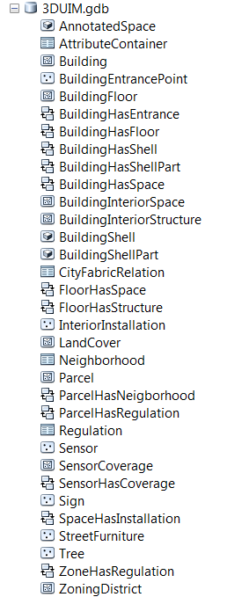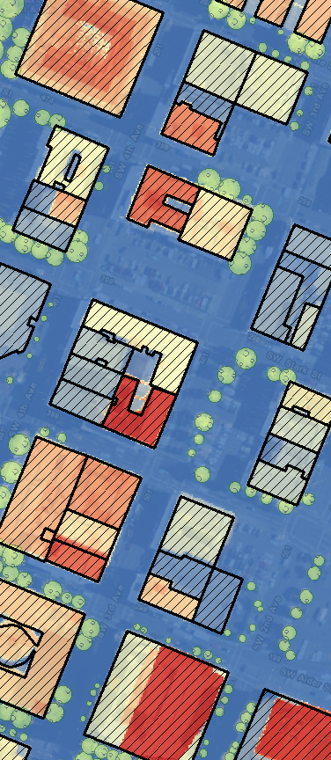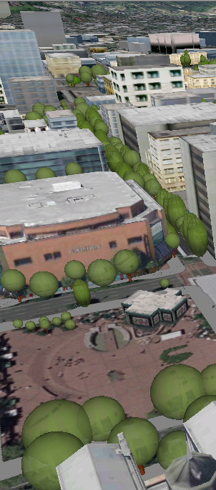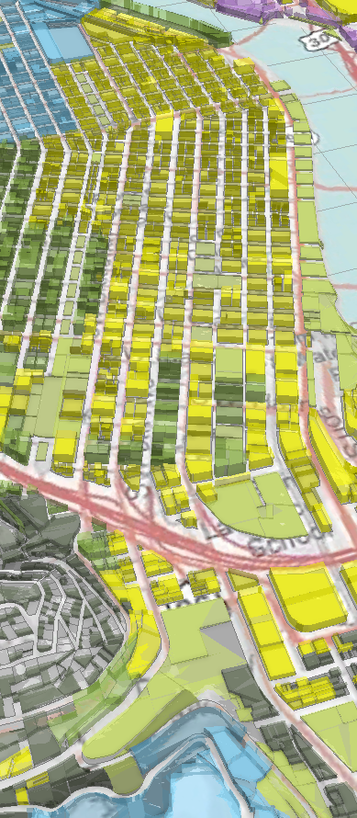
The 3D City Information Model (3DCIM) supports several 3D data management and analysis workflows
The “backbone” of the 3D City Template is the data structure, which is defined by the 3D City Information Model (3DCIM) geodatabase. This geodatabase stores features and their relationships for modeling city data at multiple scales and within three main themes:
- Built Environment: Building footprints, shells, interior features, and installations (e.g., street furniture)
- Legal Environment: Land ownership, land use zoning and constraints
- Natural Environment: Land cover features

More information on the 3DCIM itself is available from the “Overview of the 3D City Information Model” document.
The 3DCIM is designed to be compact in its structure, making the core of the model easy to populate with data. At the same time, it is compatible with important exchange formats and standards such as CityGML and the ArcGIS Local Government Information Model. Furthermore, it can be extended and localized with minor effort.

Template Contents
The following files are provided in the template ZIP file:
Template Directory | Item | Description
Apps | 3DCityAssetEditing | An Asset Editing map, geoprocessing tools, and Attribute Assistant ArcMap add-in for creating and “3D-enabling” city features like buildings and trees.
Apps | 3DCityMaintenance | A desktop application for managing and maintaining a 3D City database, from setting up the database schema to importing 2D and 3D city data.
Apps | 3DCityViewer | An ArcGlobe document for visualizing 3D city content.
Apps | 3DCityZoningDesigner | An application for incorporating zoning regulations and visualizing development potential.
Information Model | 3D Cities-1.0-schema.xml | A schema-only XML Workspace document of the complete 3DCIM geodatabase
Information Model | DataDictionary.html | Geodatabase documentation for the 3D Cities Information Model, detailing the feature classes, tables, relationship classes, and domains.
Information Model | Overview of the 3D Cities Information Model.pdf | An introduction to the 3D Cities Information Model, describing the built, legal and natural environments, database design principles, and detailed feature class descriptions.
Samples | 3DCity.gdb | Detailed workflow documentation for 3D Data import and database management
Samples | PortlandExample | A collection of sample shapefiles for the City of Portland, used in the 3D City Maintenance workflow.
Samples | Getting Started.pdf | This document. Describes how to configure template and changes made with each release.
Samples | Getting Started with the 3D City Template.pdf
Workflows
\

Software Environment
The following software must be installed:

- ArcGIS Desktop 10.1 SP1 with: (60 day trial available HERE)
  - 3D Analyst and Spatial Analyst
  - Data Interoperability Extension (or FME 2012)
- ArcGIS Server (Workgroup or Enterprise) with the following extensions, or ArcGIS Online Organization subscription
  - Image Server and 3D Analyst
- ArcGIS CityEngine 2012.1 or later (30 day trial is available HERE)
- Microsoft Excel or LibreOffice/OpenOffice

Configure the 3D City Template
You can configure the 3D City Template in your environment using the sample data provided by the City of Portland. In doing so, you’ll learn how to update and maintain 3D City features using ArcGIS Desktop and your organization’s data. Once you’re familiar with the workflows using the Portland data, use the included workflows and models to localize and apply these methodologies to your own city.

Creating a 3D City from Scratch
If you’re starting from square 1, there is a rough order of operations you should follow to construct a 3D City. These are the steps:
- Create localized 3D Cities Information Model geodatabases to hold your 3D City features. Import your existing 2D and 3D GIS data, such as building footprints, land parcels, land use regulations, trees, land cover, street furniture or transport networks you have. For specifics, please refer to the “Workflow 1 - Data Management” and “Workflow 2 - Importing and Changing Regulations” documents.
- Create a Digital Terrain Model (DTM), Digital Surface Model (DSM), and normalized Digital Surface Model (nDSM) from LiDAR data. For specifics, please refer to the “Workflow 3 – Feature Maintenance” document.
- Create and calculate building and tree heights for your city, using the nDSM raster from step 2. Refer to the “Workflow 3 – Feature Maintenance” document for detailed step-by-step guidance.
- Calculate base elevations for building footprints according to the DTM. Part 4 of the “Workflow 3 – Asset Editing” document explains the process in detail.
- Serve the DTM & any high-resolution aerial imagery as ArcGIS Imagery services. If you don’t have recent imagery for your city, the Esri World Imagery service can be used.
- Use the accompanying CityEngine projects & CGA rules to:
  - Using the Portland project, create typified building facades based on building height & number of floors > Export these to multipatch features > Import these to the 3DCIM BuildingShell features (details described in the “Workflow 4 – 3D Building Creation and Editing” document)
    - Create/apply manual textures to select buildings of interest
    - Modify multipatch geometry as needed
  - Using the PortlandBuildableVolumes project, apply zoning regulations to the parcels to create buildable volumes and export these to multipatch features for further analysis (“Workflow 2 – Importing and Changing Regulations” document)
- Construct your 3D City Globe scene: building facades, volumetric trees, street furniture, etc.
- Share your CityEngine scenes via the web with others on ArcGIS Online. (Free signup available HERE)
Template: Getting Started with the 3D City
Version: 1.0 beta
Date: November 30, 2012

Release Notes
The November 30, 2012 release is the first release of 3D City Template.

New Functionality

N/A

Resolved Problems

N/A

Known Issues

N/A

